Sean Higgins

March 24, 2017

CS 500 – Ray Tracing

Prof. Herron

CS 500 Ray Tracing – Proj. 3 Report

Overview:

Similarly to the previous project, this project was relatively straightforward and painless to implement. There were very few changes that needed to be made. All of the framework for the addition of reflective surfaces is already built in to the framework already implemented for regular diffuse lighting. The major changes occur in the various BRDF functions—both the sampling and evaluation functions require additional inputs to properly account for and calculate the new values for reflective objects—namely, the input direction and the output direction for the reflection vector, as well as the specular color and shininess of the reflective object. Aside from changing the various BRDF functions to accommodate the new additional inputs and tracking the various parameters over the different ray tracing loops, no other code or sections needed to be added to the core loop.

Output image – 4050 passes

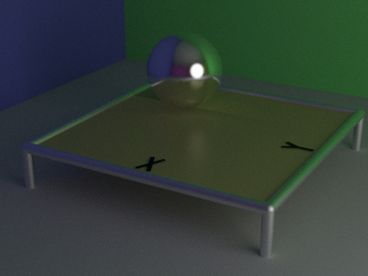

Same as above, brightened

